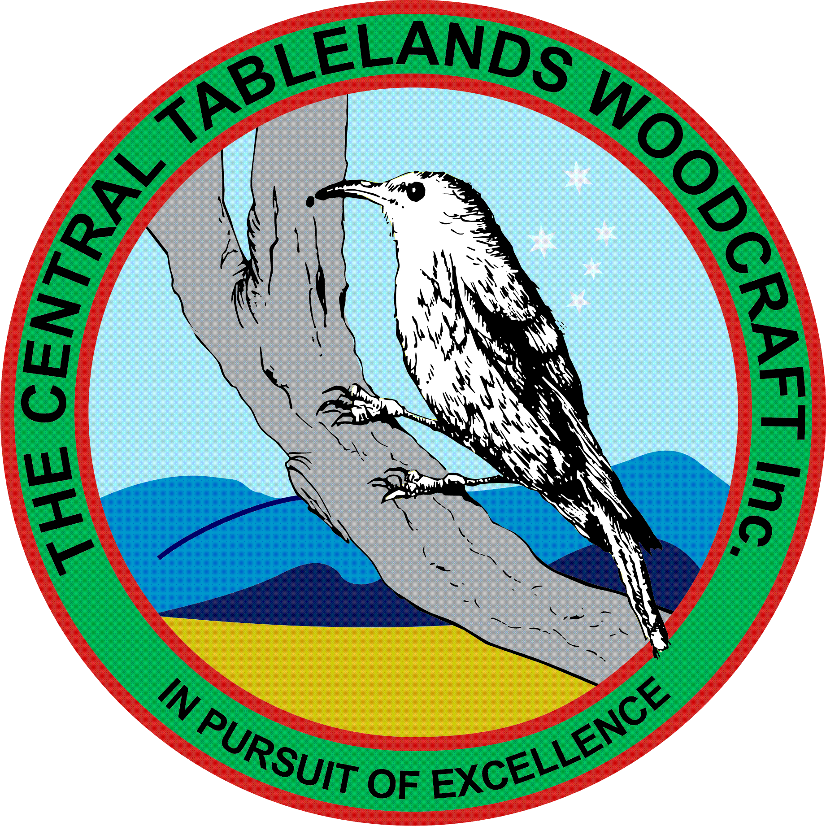
Central Tablelands Woodcraft Newsletter
November 2019
The previous meeting recommended that the Club make a one-off payment of $500 to Peter Brennan for the donated tiles used for the amenities block. The work has been completed and payment will be made when all invoices are received. There will be an official opening of the new facilities on Wednesday 11 December at 1000 with Paul Toole and Mayor Graham North attending.
CLUB PROJECTS
- Knitting Nancies Jim Hallahan (ongoing)
- Limber-jacks Colin and Paul (ongoing)
- Name Badge Box for Probus Jacko (nearing completion)
- Indoor Bowling Slide John Mc
- Kitchen Paddy
- Chair Repair Bob C
- Base for Brass Greyhound Paul R
- Modify Trophy Base Ian S

Planning for the Club Christmas Party by Bob Cassidy is underway and will be held on 13 December. The cost has gone up by $5 to $20 per person this year. Moneys will be collected up to 2 weeks prior to the party – there will be no late payments accepted.
Several of our members led by Jacko and garth have been working with a group of home-schooled children who have been learning basic woodworking skills. The first project has been a small box with basic joints, glued and nailed and finally fitted with a routed lid. It is also appropriate to mention Bathurst Bunnings for their support in this project. The programme has been going for 2 weeks and still has 3 more weeks to go.
W.O.S
It was unfortunate that during our annual wood show an amount of money up to $500 was stolen from the cash box some time during Saturday and this will be reported to the police.
Financially, the results compared favourably to last year.
It was also recommended that in future the checklist created by John McMahon should be followed to ensure that the necessary items for both the display and the advertising are taken to the showground. The number and type of categories will also be reviewed for next year.
The Workshop being conducted on Thursday mornings is continuing and will finish at the end of the school term. So fay the children have made a box, a chopping board and they will finish up with a small wooden toy.
Some Dates for you to Remember:
- Christmas Party 13 December
- Committee Meeting 20 December
- Monthly Meeting 22 December
- Sofala Show 15 March 2020
- Heritage Trades Trail 28-29 March 2020
- Bathurst Show May 2020

