Central Tablelands Woodcraft inc

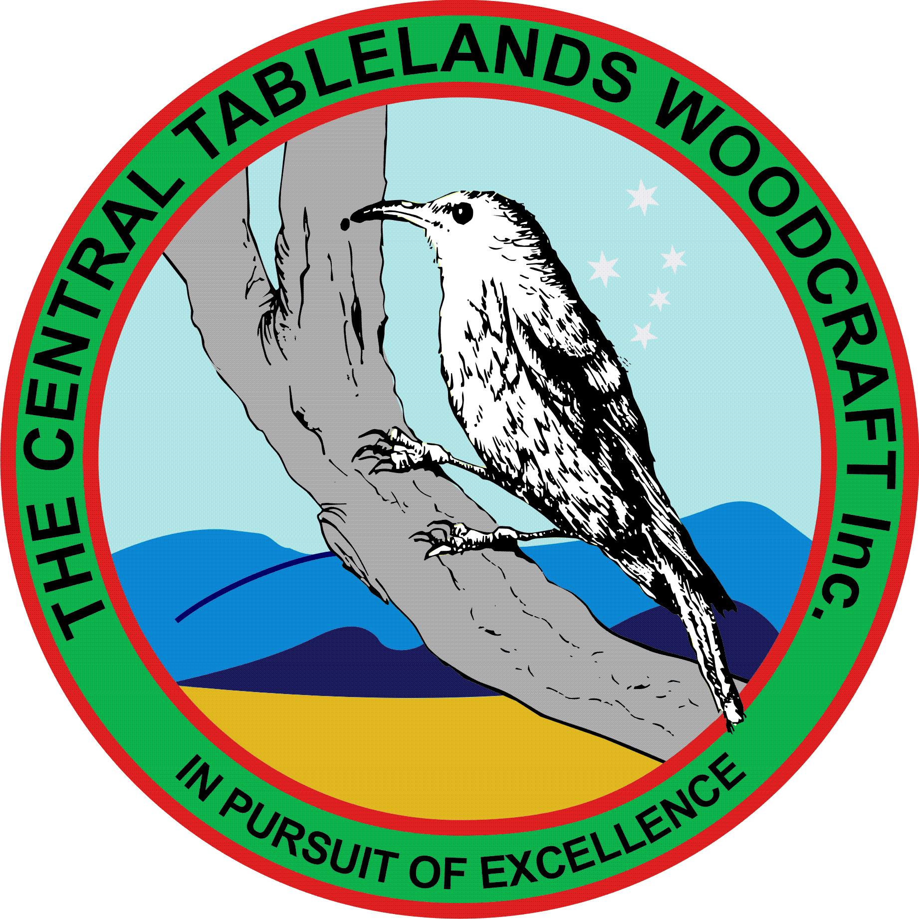

October 2017 Newsletter

With W.O.S fast approaching our focus is no on the planning and preparation for this event. As this is the Club’s major event for the year and that it is the most important way we present ourselves to the general public it is important that ALL members make a huge effort to participate.
This year we will be having demonstrations, exhibitions and sales tables so there will be

Members of the Club have been very busy making items for our special projects as well as themselves either for sale or for display at W.O.S in November – keep it up.

We have also welcomed some new members to our Club who are fitting in very well and are starting to make items for themselves.

The extra machinery in the workshop – mainly the 3 phrase lathe and table saw have been wired in and set up and are being used. Our members who are undertaking this work have done an outstanding job – congratulations.

President John has been very busy obtaining sponsorship moneys for W.O.S and we now have no only what we require to run this event but also to provide suitable and adequate prizes for the competitions.

Speaking of competitions – this year we have expanded the competitions to include a “Novice” section for each category to include everyone regardless of their skill levels. I encourage ALL members to submit items into the competition – this will enable you to improve your skills into the future – so get making.

Again a huge thank you to Ian Schiemer for all his hard work in tidying up our tool board, the store room and the other items he has either made or re-arranged.

A representative from St. Johns came and demonstrated toe AED to the members present on the day and all those members gained an understanding of how to operate the machine.

It has also been great to Bill back and to have the occasional visit from Les and Michael Nassar – great to see you guys.

