We are proudly supported by
President | Graeme Turner | 4111 3066, 0437 510950 | bluey@internode.net.au
Vice President | Anthony Byrne | 5148 2816, 0413 022113
Secretary | Ian Henderson | 0408 361848 | hendo1@bigpond.net.au
Treasurer | Norm Hyde | P O Box 842, Sale, 3853
Newsletter | Graeme Turner | 4111 3066 | bluey@internode.net.au
Email | Gippslandwoodies@outlook.com

Committee | Stuart Baird | Paddy Boyce | Michael Sibley
 | Ian Henderson | Ralph Chilver | Roger Langford
 | Graeme Ingleton | Andrew Knowles | Peter Vranek
 | Ross Noske | Len Graham | Robert Ahearne

GIPPSLAND WOODCRAFT GROUP INC.
Registered No. A 7473
P.O. BOX 179, HEYFIELD, VIC. 3858

MEETINGS HELD ON
2nd & 4th SATURDAYS OF THE MONTH
GIPPSLAND WOODCRAFT GROUP HALL
843 MAFFRA / ROSEDALE ROAD, (C487) NAMBROK
from 10.00am

THE WOODY-WOODWORKER
NEWSLETTER
No. 373 – NOVEMBER 2018

MINUTES OF MEETING HELD AT THE
CLUB ROOMS, NAMBROK, OCTOBER 13th 2018

President Graeme Turner opened the meeting at 10:00am and welcomed those attending.
MEMBERS PRESENT: Alex Prodanovic, Andrew Knowles, Anthony Byrne, Ashley Thompson, Ben Thompson, Brian Wills , Colin Elmore, Cyril Hibbert, Denis Booth, Freeda Peel, Geoff Howe, Glen Bradley, Graeme Ingleton, Graeme Turner, Graham Frankland, Henry Winters, John Brei, John Cruickshank, John Pritchard, Karen Petrovic, Margaret Beckett, Margret Lamb, Mathew Thompson, Maurice Gunnulson, Michael Sibley, Norm Hyde, Paddy Boyce, Peter Vranek, Ralph Chilver, Rob Wetton, Robert Ahearne, Ross Neilson, Ross Noske, Stuart Baird, Taffy Sault , Yvonne Bradley
Visitors: Sheryl English, Frank Ameerberg, Kevin Schridhazios
Apologies: Colin Macreadie, Ian Henderson, Jeff Reid, Roger Langford, Ron Helleren,
Guest Speaker: Frank Ameerbeg
Minutes: As per the last newsletter the minutes were moved as correct by Anthony Byrne and seconded by Brian Wills. Motion carried.
Treasurers Report: Balance: $22,713.20
Norm Hyde moved the treasurer’s report be accepted seconded by Brian Wills. Motion carried.

Correspondence:
- Newsletters from various clubs.

Anthony Byrne moved the correspondence be accepted seconded by Peter Vranek. Motion carried.

General Business:
- Graeme Turner has been contacted re 4 red gum roadside posts in various sizes, contact Graeme for further details if interested.
- Bus trip to Pop’s Shed 17 November if there are sufficient numbers and a driver can be found.
- Paddy was given another carton of hinges, $5 per pack.
- Just a reminder that when locking up the clubrooms make sure that ALL of the lights are turned off.
- A deckchair has been dropped off at the clubrooms for repair, volunteer required, see Graeme for details.
- Mini Lathe for sale, Record lathe & 8 Robert Sorby tools, contact Graeme for further details. $500
- 4 trestle tables in the shed need to be sanded & stained, volunteers.
- Taffy is making a Wedding arch for Kylie.
- Maffra Show 26 & 27 October, 1 spare ticket if you would like to help see Ben Thompson for details.
- 100 Spirit levels have been delivered ASH, Thanks Ian. Another job for ASH has been picked up, 50 monitor blocks.
- Ian has oiled the bottle openers for ASH volunteers required to glue the inserts in.
- The club has purchased an ALDI SIM card for the security system to replace the Telstra card, much better deal.
- The large table in the workshop requires the legs to be reattached and 2 coats of polyurethane applied, volunteers.
- Farm relief event at Rosedale 20 October, attending are Karen & Andrew any other volunteers.

Meeting Closed:10:30am
GETTING AND SPENDING
During September we received a $2000 grant from Wellington Shire for the newly installed security system, while Ralph Chilver has been busy manufacturing two golf shields for which we received $200.
Various items purchased by the National Timber Councils Association sold for $244, the hardwood potting bench constructed at the club went for $200, and sales at the CWA craft fair in Sale totalled $15.
Two cutting boards made $10, end sealer $4, seven boxes of donated hinges $35, while the second hand air conditioner was sold off for $50.
Our monthly raffle brought in $60, door entry $196, subs $50, catering $23, and $60 has been received in payment for the Christmas lunch.
Our security system, paid for by the Wellington Shire grant, cost $1995; from Bunnings we purchased shelving for $321.10 (which came in as part of the LVA grant) for the Graeme Turner Shed; and stain, bench top oil, pine and 30mm dowel for two bar tables costing $314.94 also came from Bunnings.
Our Wellington Shire rates and fire levy came due at a cost of $287.37, we purchased two additional height adjustable chairs for $576, an internet SIM card $150 and an orbital sander pad was $34.95.
Heyfield Signs updated the honour board for $27.50, while sugar, soft drink, water, milk, bread and bathroom supplies amounted to $74.05.
On September 30 we had $22,713.20 in our Bendigo Bank account.
NORM HYDE, Treasurer
For payments to the club, these are our Bendigo Bank details: BSB 633-000. A/c No. 1477-77080. Or place the payment in an envelope, detailing your name, the amount and its purpose, and hand it to Treasurer Norm.
SHOW AND TELL
Graeme Turner showed two bird boxes he made from Cypress they are the first of 20 to be made for the Traralgon Railway reservoir conservation.
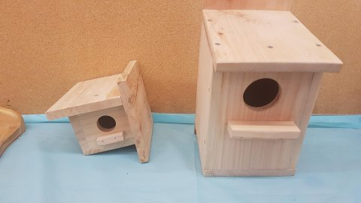

John Cruickshank turned 2 items from Mahogany a shallow dish and a pot-pourri bowl
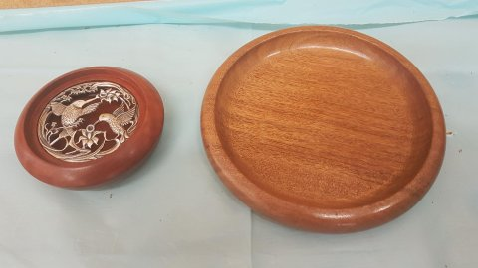
both items were finished with water based.

Geoff Howe made a tablet stand with a blackwood base and water base lacquer and a serving tray from Claret Ash and finished it with a pour on resin.
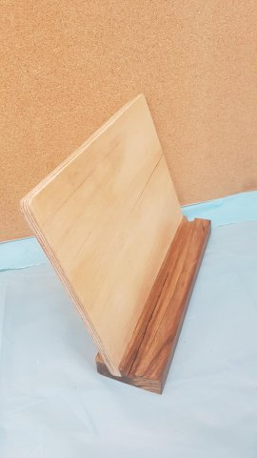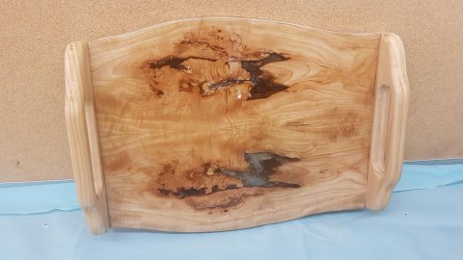
Ben Thompson turned a small bowl from timber unknown. a 25mm x 50mm ring box from American walnut and 2 small lidded trinket containers from Red Gum and Osage Orange all items were finished with EEE and shellawax.
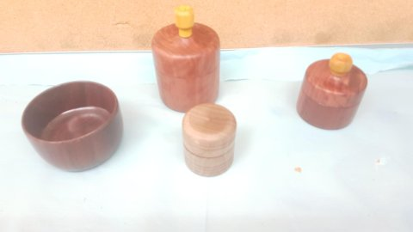
Ralph Chilver turned a pot-pourri bowl from spaltered Pittosporum and a ring holder from Red Gum both items were finished with shellawax.
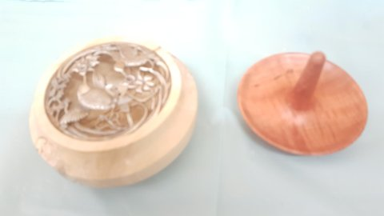

Graeme Ingleton made a gavel and base from Red Gum and finished them with wipe on poly this item was a club project.
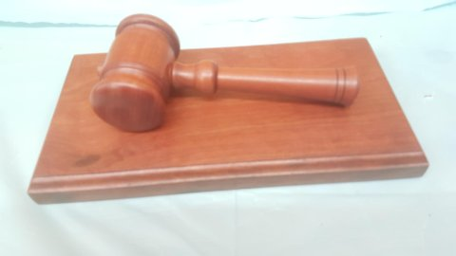
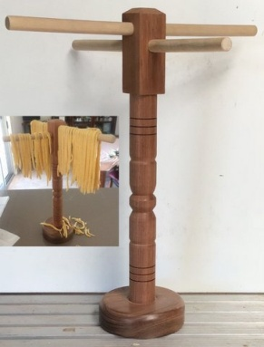
Norm Hyde made a 440mm high pasta drying stand from Blackwood and a hardwood unknown.

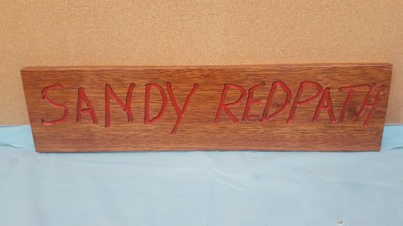
Brian Wills made a wall sign from Mirbau he did it free hand with a mini router it was painted cherry redand finished with clear lacquer.

Taffy Sault made a small 700mm x 350mm table from a slab of Huon Pine the natural edge gives it a lovely look he finished it with water based cabots cabothane clear.
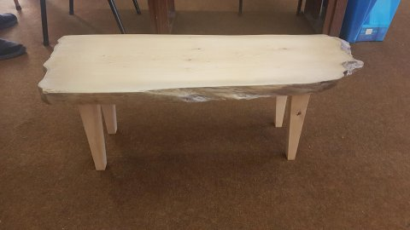
Taffy commented it was nice timber to work with.

SATURDAY MEETING
A short meeting and excellent show and tell was followed by a demonstration on making lace bobbins which was presented by Frank Ameerbeg. Frank gave a very detailed talk and turned out some very well finished bobbins. A number of questions were answered and I am sure we will be seeing a lace bobbin or two at future show and tells.
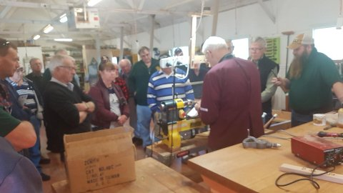
WANTED KNOWN
If you need to enter the club rooms between meetings you will need to contact one of the following people
Paddy Boyce 0429 422 207 Anthony Byrne 0413 022 113 Ian Henderson 0408 361 848
Norm Hyde 0427 314 879 Graeme Turner 0437 510 950
Michael Sibley 0427 446 194

4TH SATURDAY
A very productive day was had, a team worked on installing the opener mechanisms into the turned holders which were then bagged and boxed in readiness for delivery to ASH. Ian, Michael, Taffy and some quality checkers fitted the legs and braces back onto the large table we are overhauling, Taffy gave the legs another coat of stain and it is planned to apply some clear finish to the table and benches between now and the next meeting so it can be picked up by the owner soon. John Cruickshank made a start on a nice bowl, Ralph, Ross Neilson and I fitted the spouting brackets to the front facia and later Ralph and Ross fitted the stop ends to the guttering. We were given an outdoor chair to repair so Ian and Taffy disassembled the damaged parts so new ones can be made up by Taffy. About twenty six attended today’s meeting which is lower than usual but Paddy and Pam’s wedding and the Maffra show kept some members busy elsewhere.
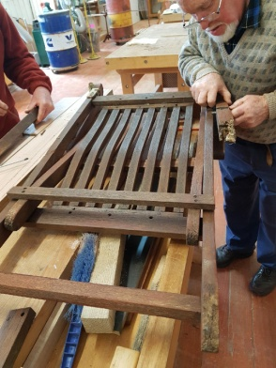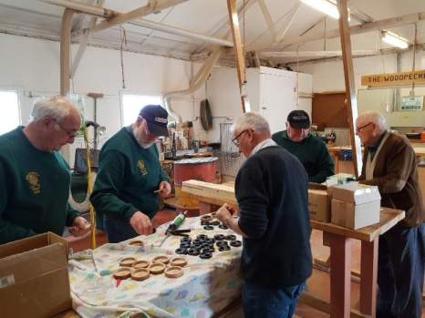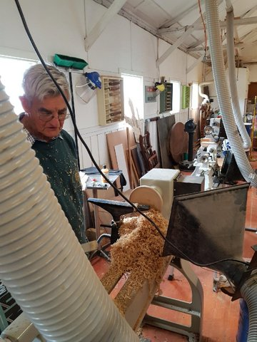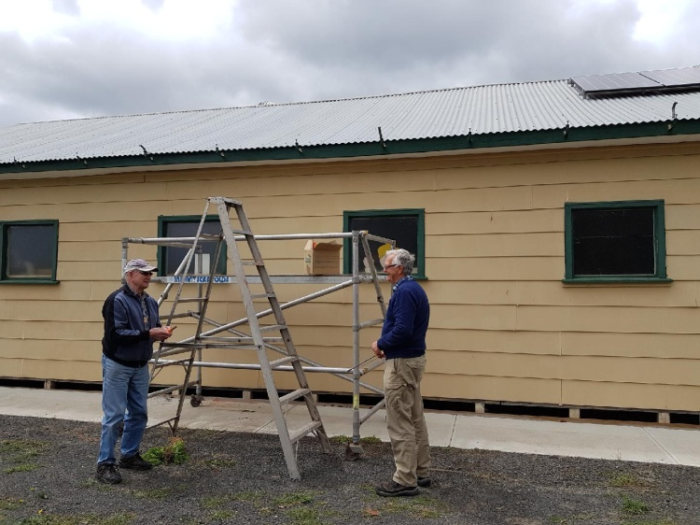
FARM RELIEF. . . .
Karen, Andrew and Paddy attended the farm relief event in Rosedale but due to a very poor attendance the stall holders began leaving early and while the original plan was to run until 9pm our team were one of the last to leave and were out around 4pm. A few tops were handed out.

PENS POPULAR AT MAFFRA SHOW
Ben, Ashley, Brian and Maurie had a productive and enjoyable two days at Maffra Show on October 26 and 27.
Friday was spent outdoors under the gazebo, moving into the pavilion on Saturday.
Many inquiries were made about the club, with a steady stream of youngsters lining up for tops, while the sales table created much interest.
Ben and Ashley were kept busy turning and assembling choose-your-own pens while Brian and Maurie cut out animals with the scrollsaw and fretsaw.
Wil and Tara were thrilled with their pens made by Ben and Ashley
Norm
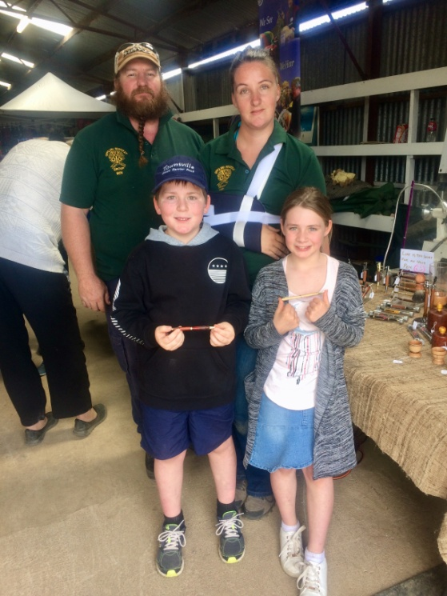
FOR SALE
Peter Vranek has some dry red gum slabs for sale
2 @ 550 x 800 x 45 that are 2.8 meters long $400 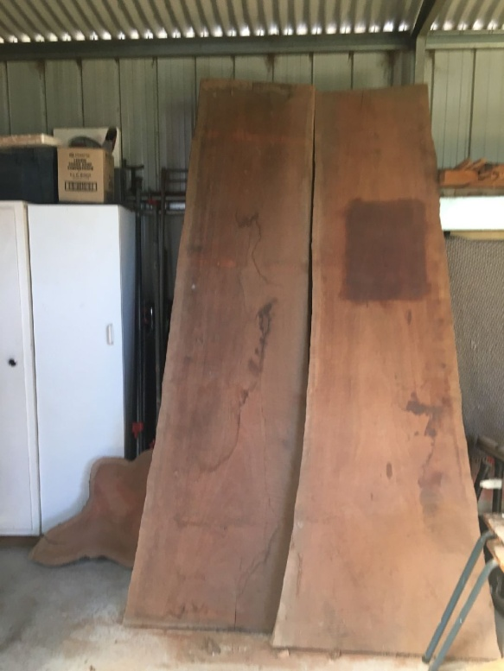 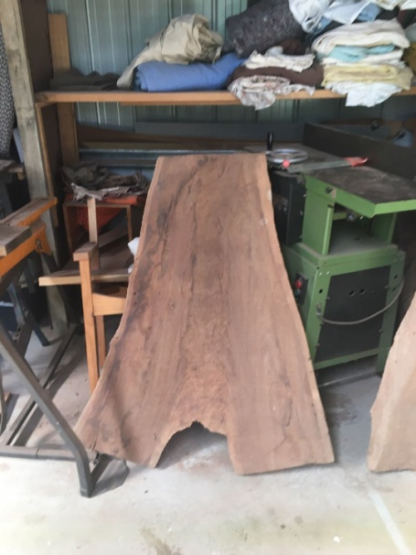
2 @ 450 x 850 x 45 that are 1.100 long $100
For details phone Peter on 0401 151 187.
------------------------

Stuart Baird has a Vic Mark lathe for sale
VM 150 lathe, live centres, spurs drives, 3 scroll chucks, bed extension, face plates. This is a very solid and reliable lathe and great value at $1500.00. For more details contact Stuart on (03) 51497159

Show and Tell | Activity
November 10th  Christmas Decoration | Chris will give a talk about drones and do a demonstration
December8th  FREE CHOICE | Spinning top contest
January 12th2019  An item made using  Red gum | Suggestions welcome
February 9th 2019  A wooden container | Volunteer required

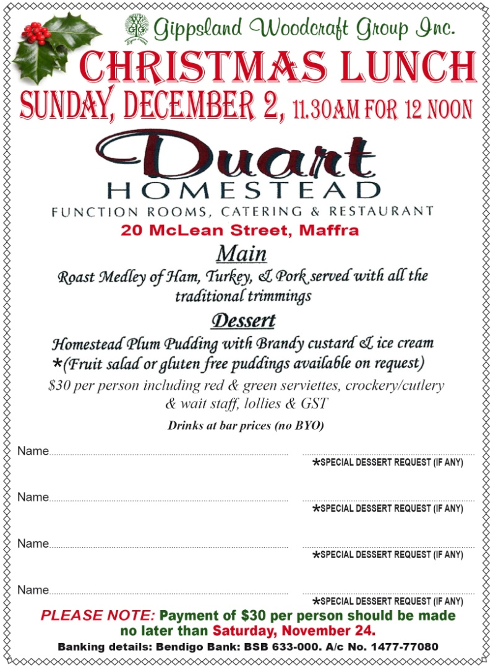

SPONSORS
We greatly appreciate the support of the following sponsors and urge all members to keep the phone numbers handy and support them where possible

RTL Earthworks, Moe – 5136 1000 | Harvey Norman, Traralgon – 5175 6700
Morelli’s Furniture & Bedtime, Sale – 5144 7099 | Holcim Concrete, Morwell – 5133 4800
Kencor Sales (Bolts etc), Morwell – 5133 7765 | Pro Draft Pty Ltd, Architects, Morwell – 5133 8007
Carpet Country, Sale – 5143 0266 | Willaton Transport, Morwell – 5133 9000
Southern Rural Water, Maffra - | Bunnings Warehouse, Traralgon – 5172 1000
Bendigo Community Bank, Heyfield | Ranford’s Family Butcher, Sale – 5144 4370
Engie | Pop’s Shed, Chirnside Park – 03 9727 0611
Wellington Shire Council | Matthews Quarry – 5174 3131
Australian Sustainable Hardwoods, Heyfield | Heyfield Signs – 5148 2822/0419 171682
Steeline Roofing – 5176 5866

GIPPSLAND WOODCRAFT GROUP
P.O. Box 179
HEYFIELD, VIC. 3838

«APPL» «FIRST» «LAST»
«ATT»
«ADDRESS1»
«ADDRESS2» «PCODE»

