Sauctiomed off

Port Stephens

Community Woodworkers Inc.

Woodnews

Official Newsletter of

**Port Stephens Community Woodworkers Inc.**

P.O. Box 425, Nelson Bay NSW 2315

Vol. 276 No 4 May, 2022

**ABN 16 502 165 623 Website.** <http://www.pswoodworkers.com.au>

Ines

**CLUB OFFICE BEARERS 2021- 2022**

**Workshop Phone Number 0478 935 847**

**Patron** **Frank Future**

**Executive**

**President Roger Delaney 0423 588 232**

*(president@pswoodworkers.com.au)*

**Vice President TBA**

**Secretary Jim Papworth 0401 000 439**

*(secretary@pswoodworkers.com.au)*

**Treasurer Keith Bryars 0418 884 482**

**Elected Rep.1 Stewart Upton 0411 588 361**

**Elected Rep 2 Bob Parrish 0407 103 933**

**Workshop Mgr. Dave Bear 0434 267 101**

**Community Liaison/Publicity**

**Officer Ines Thomas 0416 199 551**

*(*[*coordinator@pswoodworkers.com.au*](mailto:coordinator@pswoodworkers.com.au)*)*

**~~~~~~~~~~~~~~~~~~~~~~**

**Assistant Workshop Managers:**

**Bob Parrish 0407 103 933**

**Stewart Upton 0411 588 361**

**BBQ Supervisor Ken Richards 0475 248 306**

**Office Manager Graham Miller 0439 437 047**

**Woodnews Editor TBA**

**First Aid Officer Fred Harvey 0415 640 289**

**Public Officer Keith Bryars 0418 884 482**

**Welfare Officer Bob Grant 0407 402 253**

**Web Master John Foster 0423 721 875** (*web@pswoodworkers.com.au)*

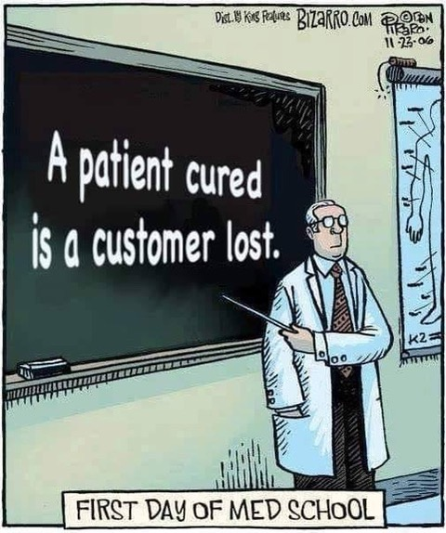

**Dates to Remember**

|  |  |  |  |
| --- | --- | --- | --- |
| **June Monthly Meeting** | **Tuesday** | **14th June 2022** | **1.00 p.m. Workshop** |
| **School Projects** |  | **All cancelled** |  |
| **Bunnings BBQs** | **Saturday** | **27th August** | **9.00am till 12.30pm**  **12.30pm till 4.00pm** |
|  |  |  |  |
| **Christmas Party** | **Thursday** | **15th December 2022?** | **6.00pm – 10.00pm** |

**SHOW AND TELL**

There was no show and tell this month but Bob Parrish has completed his massive garden seat and finished it off at home. It’s made from mountain ash, has 52 mortices and was finished with Estapol. Some project!

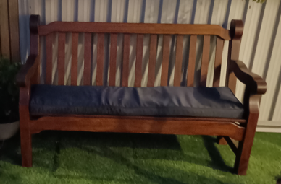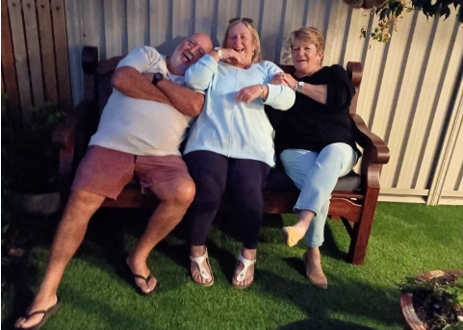

**The finished garden seat and the road test – obviously a pass!**

**WELFARE REPORT**

**By Bob Grant**

**Graham Miller:** Graham’s surgery didn’t take place as a result of a false diagnosis. He is okay and doing well.

**Steve Cuffe:** Last month I advised that Steve had some serious eye surgery, the result of which was that he had temporary blindness, meaning he could only distinguish light from darkness in that eye. His vision has since returned to almost as good as it was before the operation. He needs further surgery in 6 months’ time to correct a cloudy lens. He is back driving and can now get to his favourite store, Bunnings. Well done, Steve.

**Bob Parrish:** Bob had some exploratory surgery on the 2nd May which revealed that his bladder cancer had returned. He is scheduled to have a series of injections over 6 weeks, commencing Thursday. The prognosis is good with this chemical treatment having a 92% success rate. We are all behind you on this one, Bob.

**Stewart Upton:** Stewart’s wife Dorothy has had a recent brain scan and the result showed no sign of her previous brain cancer. This is fantastic news. She will be seeing her Lung and Liver Specialist in a few weeks to check on any other areas of concern. All the best, Dorothy. Meanwhile, Stewart is doing okay.

**George Falzon:** George recently spent an unexpected 10 days in hospital relating to a previous complaint. He has responded well to treatment and is improving slowly. He will be seeing his GP next week to confirm that everything is okay.

**TID BITS FROM THE SHED**

**Australia’s Biggest Morning Tea**. At our monthly meeting, we agreed that we would support the morning tea that is being organized by the Patchwork group in the Art Centre. It’s being held on Tuesday, 24th May and commences at 10.30am. The entry fee is $5 and there will be a raffle, a lucky door prize and trivia. Please bring a plate. Let Roger know so that the numbers can be passed on to the AC.

* **Bunnings BBQ.** The BBQ on Saturday 14th May was held in great weather under a blue sky. Again,we were located outside the main entry/exit and after a slow start we finished up making $800 profit. The morning shift crew were a bit camera shy, however, we managed to get a photo of the sfternoon shift - but where’s Ken Richards, our BBQ chief executive and all round super hero/organiser?

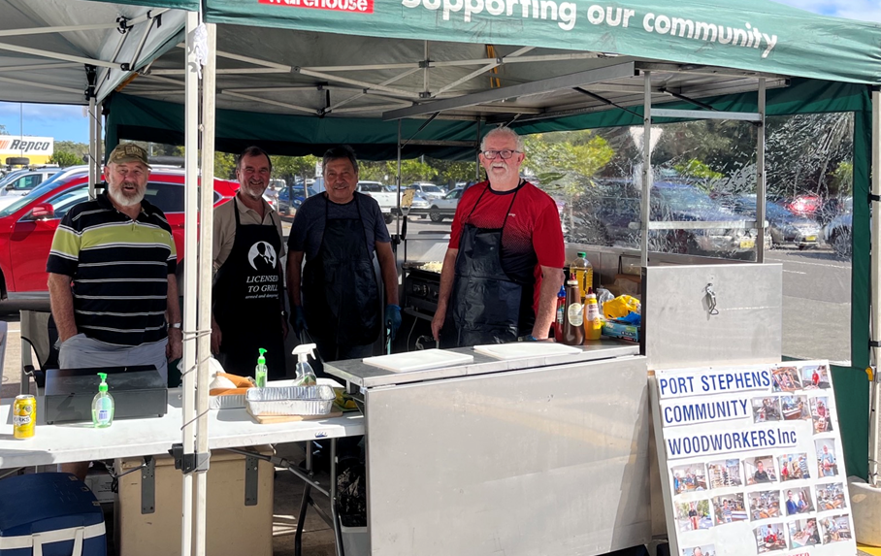

The Afternoon Shift

* 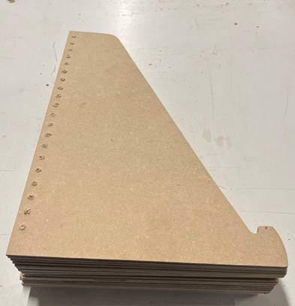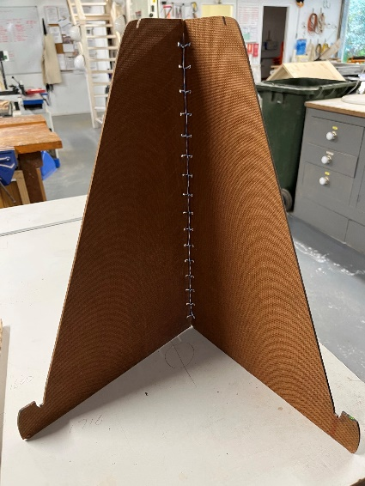**Table Stands.** The AC asked if we could make up some table stands, for their display, like the one shown here on the left.

I was planning to use the bandsaw but Dave made up a template for use on the router and we cut 22 out in just a few minutes, as on the right.

Dave then made up another template for the drill press for the holes, so they are all perfectly aligned.

Easy when you know how!

The AC were delighted.

* **School Kits.** Ines has done a stock take of our school kits. On the notice board, she’s put up the kits and the numbers that we need to make to bring our stock levels up in readiness for the restart of school projects. If you have spare time, please check the board, work in pairs and get cracking 😀.
* **Karingal Pre School**. We have a booking for 1st September and need 50 toolboxes. Good work Ines.
* **AGM.** The AGM is fast approaching and we need people to consider standing for the Executive and Non-Executive roles. It’s your big chance to fix all those things you think need fixing. Don’t leave it to the same people all the time – we’re always looking for new blood! Just speak to a committee member if you have any questions. See the list of positions at the top of the Woodnews.
* **Christmas Holiday Raffle.** Any ideas on what we should make for our Christmas raffle will be welcome. Please give it some thought.
* **Woodnews.** We’re still looking for a Woodnews Editor! (was that an echo?). The job comes with a laptop and a printer. Training can be thrown in free of charge along with on-going support. If no one puts their hand up the next issue will be the last after 25 years.

**Jokes of the Month** MONTH

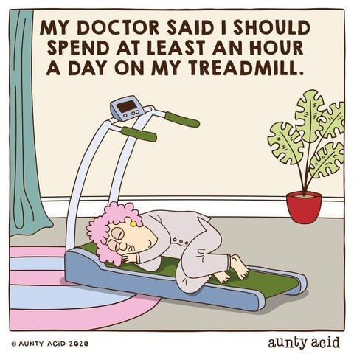 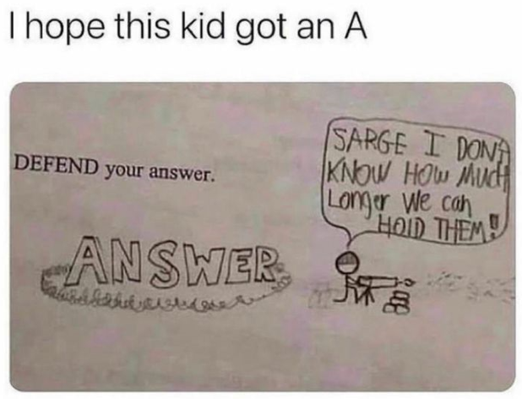

 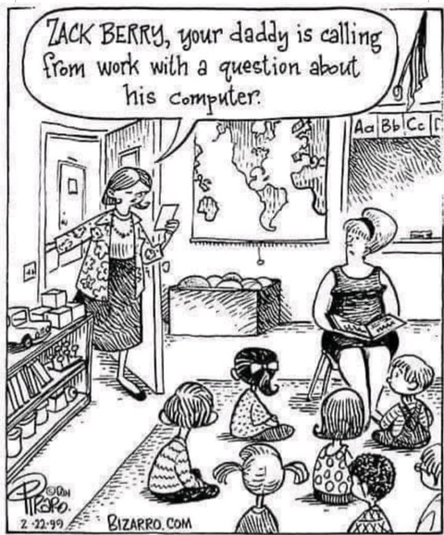



**The Watch**

James Bond walks into a bar. He looks around, and takes a seat next to a very attractive women.

He gives her a quick glance, orders a martini, then causally looks at his watch for a moment.

The women notices this and asks, "Is your date running late?"

"No", he replies, "Q has just given me this state-of-the-art watch. I was just testing it."

The intrigued women says "A state-of-the-art watch? What’s so special about it?"

Bond explains "It uses alpha waves to talk to me telepathically".

The lady says "What’s it telling you now?"

"Well, it says you are not wearing any panties."

The women giggles and replies, "Well, it must be broken because I am wearing panties"

Bond smirks, taps his watch and says,

**"Bloody thing's an hour fast"**

**Memorial Stone**

Sam died and left $50,000 in his will for an elaborate funeral. The family were all there and the service was well attended with lovely eulogies and the Woodies formed a guard of honour, as everyone exited the church.

As the last attenders left, Sam’s wife Rose turned to her oldest friend Sadie and said: “Well, I’m sure Sam would be pleased, it was a beautiful service.”

“I’m sure you’re right,” replied Sadie. She leaned in close and lowered her voice to a whisper. “Tell me, how much did it really cost?”

“All of it,” said Rose. “Fifty thousand.”

“No!” Sadie exclaimed. “I mean, it was very nice, but really… $50,000?!”

Rose nodded. “The funeral was $6,500. I donated $500 to the church for the priest’s services. The food and drinks were another $500. And the rest went towards the memorial stone.”

Sadie computed quickly. “$42,500 for a memorial stone? Exactly how big is it?”

**“Seven and a half carats.”**

**The Pen**

Paddy finds a pen and says to Mick, “Is this yours?”  
Mick says, Give it here and I’ll try it out.

"Yep, it’s definitely mine”  
“How do you know?” asked Paddy  
**Mick says, “It’s my handwriting**