**COVID NEWSLETTER # 4**

Another week has passed with more contributions for our Newsletter, for which many thanks. Please keep them coming in.

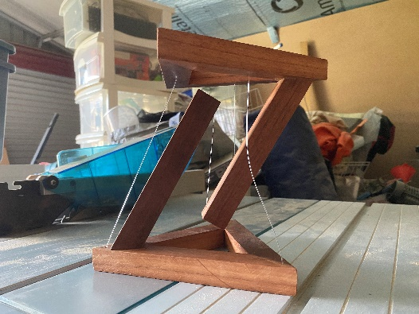**Paddy** forwarded this picture of a tensegrity (to the left) he has made from his old (jarrah?) bench timber

*(According to Wikipedia*

*Tensegrity, tensional integrity or floating compression is a structural principle based on a system of isolated components under compression inside a network of continuous tension, and arranged in such a way that the compressed members (usually bars or struts) do not touch each other while the prestressed tensioned members (usually cables or tendons) delineate the system spatially ).*

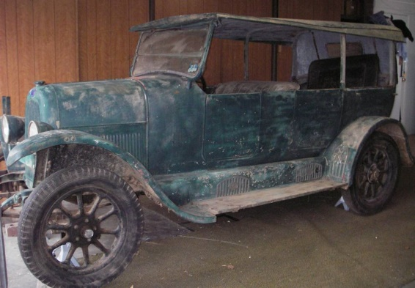One of **Doug’s** many projects…

The vehicle is a 1924 Fiat 501.  It was left on my father in law’s property at Oberon when the owner passed away in the 1960’s. The owner had adapted it as a rabbiting vehicle on the property, and as such, has no back seat. The owner’s widow said that my father in law, Merv Brien, could keep it.  Merv kept it in a shed on the farm, and then moved it to his shed in Oberon town when he sold the property.

The car was last registered in 1959.  It has been in my hands for over decade after Merv passed on in 2008.

While the body skin is steel, there are many **wooden** parts including the body and door frames, dashboard, number plate holder, running boards and the cabin floor.

I found a person in Gympie who has owned and restored one, and he has able to send me a copy of a parts manual and user manual, but it is all written in Italian. It looks like I will have another language to learn!

A goal is to hopefully at least get the car to drivable stage again by the time it turns 100 years old in 2024.

**Brian Clymo** reports “in the past couple of weeks I have been busy making a queen size bed, bedhead and 2 bedside tables from pallets (see photos) as requested by my stepdaughter and her husband. They recently moved and were sleeping on the floor.  Lorraine and I delivered them yesterday. They loved them and I understand they had a good sleep last night”.

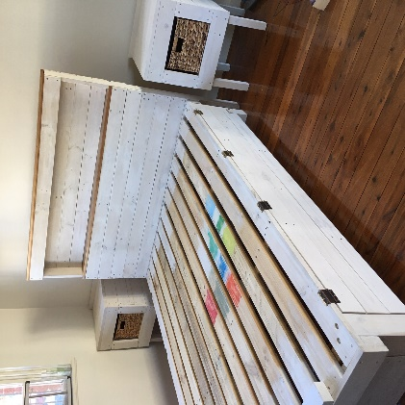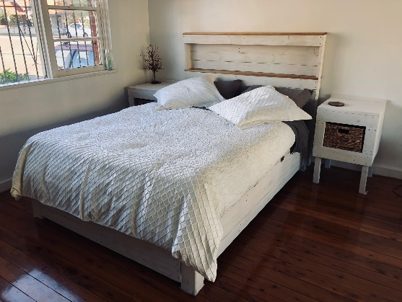

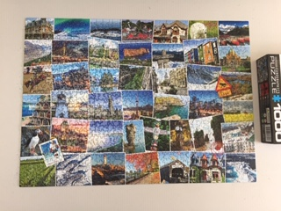 **Steve Ghent** reports: I received this 1000 piece puzzle last Christmas from my sister, who now lives in Canada. It is made up with postcard type pictures of various scenes in Canada.

It has remained, unopened, in a cupboard since then. Along comes the Coronavirus lock up!  
What to do to keep fingers and brain active during this time?  
Well the puzzle got opened and set up on a large spare table. It is surprising how much space it took up. It has kept me entertained for several hours and gave a nice feeling to see it completed at last.

**Windsor stool making workshop**

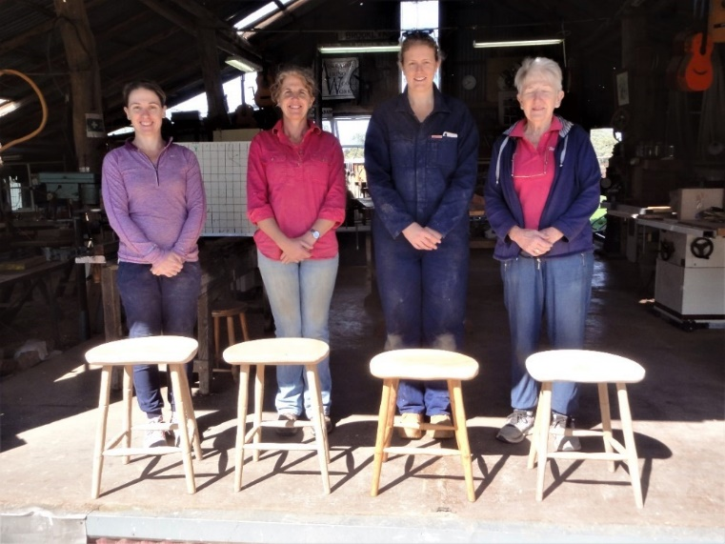**.**

In March John and family spent five days participating in a Windsor stool making workshop at Molong. Three of the four women had very little prior woodworking experience and none of them had had any experience with this sort of woodwork.  Marie- Louise had made a Windsor chair the previous year with Howard Archbold at Moonan Brook.

At  the end of the five days four very proud women were photographed with their lovely stools.

*Stephanie, Marie-Louise, Sarah & Kathy*

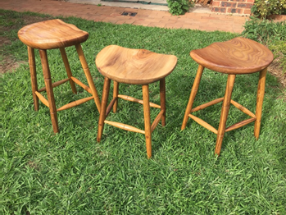The stools were made by hand with no electric machines being used.

John didn’t actually make a stool but instead assisted the ladies with their works.

*the McMahon stools finished with Danish Oil*

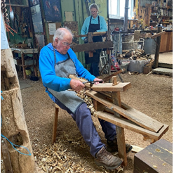 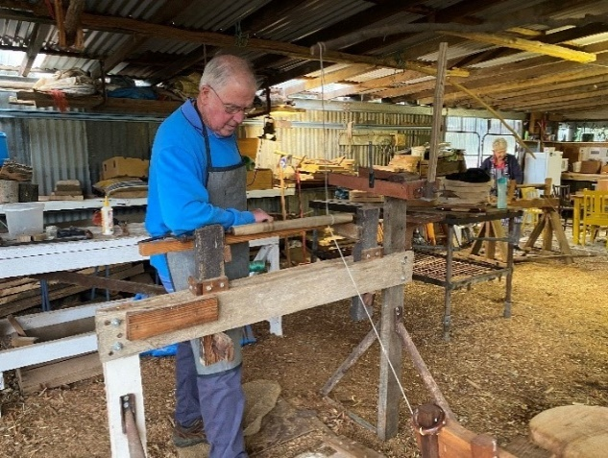 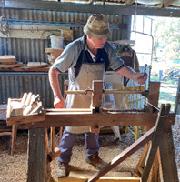

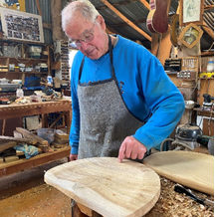  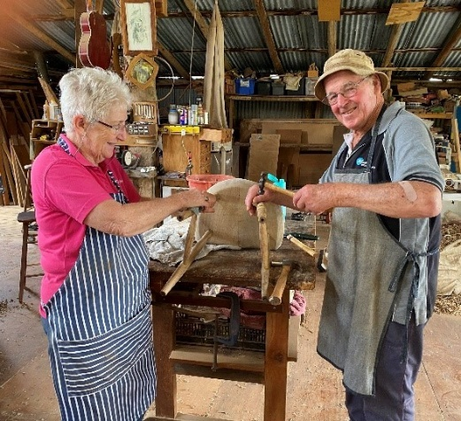 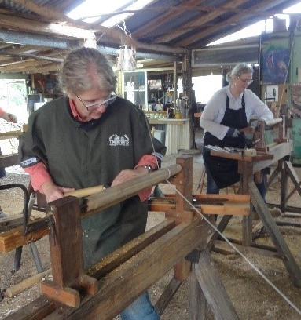

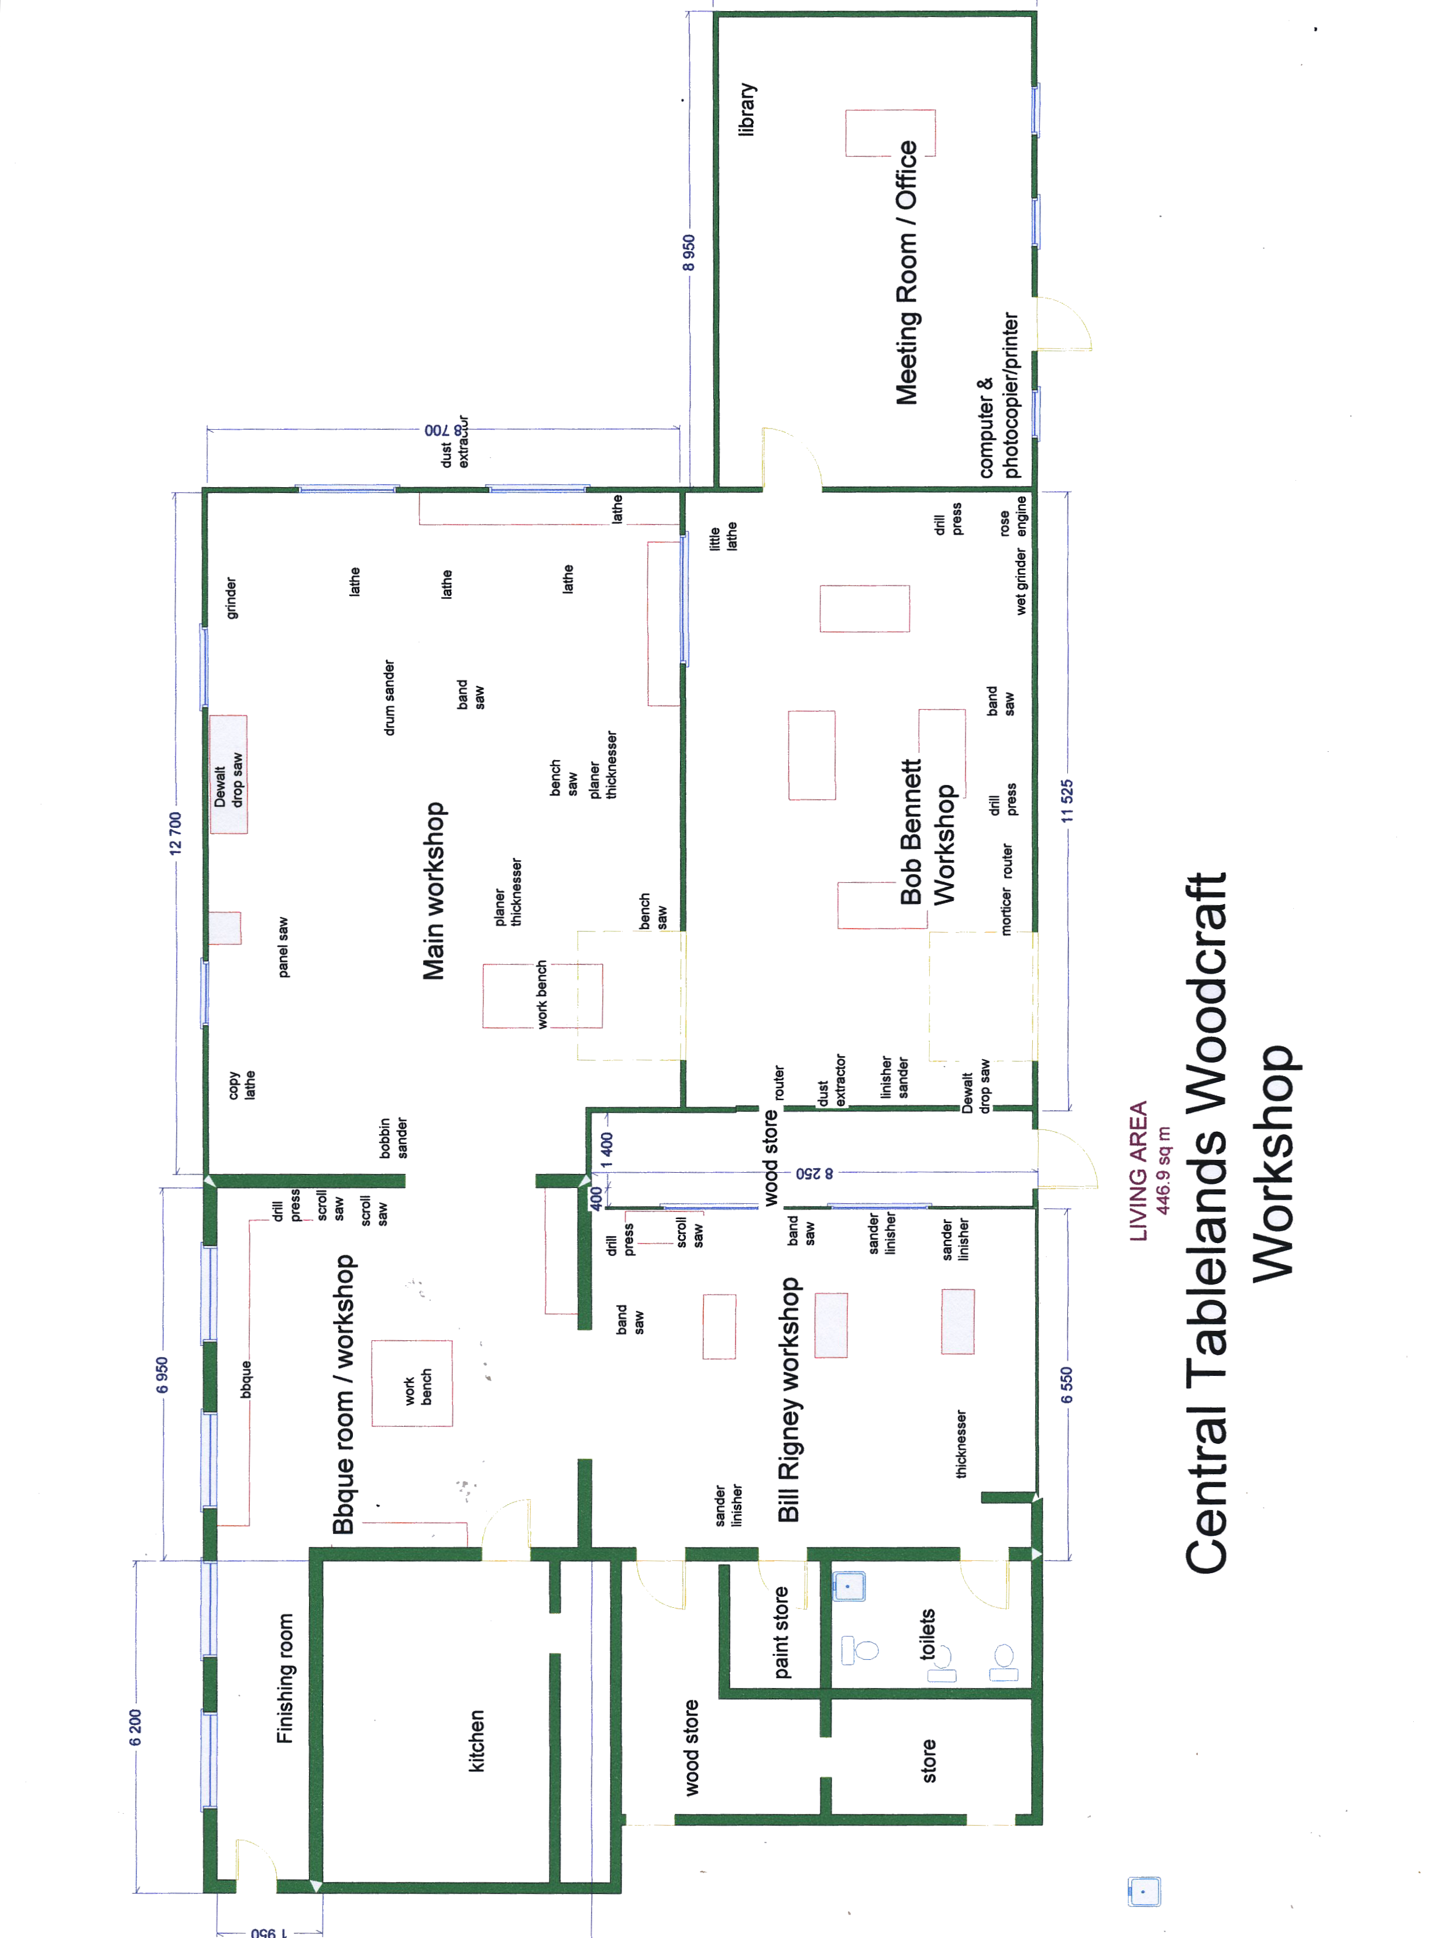

**IMPORTANT PLEASE TURN OVER**

**To explain why I’ve included a floorplan of the workshop…**

**This is the first time the CTW has been closed for any length of time – so, with the equipment put under wraps and regular inspections continuing of the building, now is a golden opportunity to step back and think about our organisation.**

**At last month’s AGM I said that my vision for the Woodies was**

* **To be inclusive and welcoming to all comers. To encourage anyone with an interest in wood to come and join us**
* **That everyone feels valued and supported in their endeavours**
* **That no-one ends up wanting or trying to do everything**
* **That everyone is encouraged to contribute to the successful running of the organisation in whatever way they feel able**
* **That you come here, not only to work on your particular project, but to spend time and have fun with like minded people.**

**So what I’d like you to think about in the next couple of weeks is to jot your thoughts down under the following headings –**

* **What you like about the Woodies/why you come to CTW**
* **What you don’t like about the Woodies, and what we can do about it**
* **And your ‘What if … ‘ and ‘If only….’ thoughts… to make it an even better place**

**Nothing is off limits – all I ask is that, wherever possible you give specific examples, rather than sweeping generalisations.**

**As you can probably guess, I have plenty of ideas, but I’d like to hear yours too, so now is your opportunity!**

**Use this sheet/extra sheets to write down your response and drop it into the Woodies, post it, or email me if you prefer. (elizabethsforbes@hotmail.com)**

**Please don’t pass up this opportunity to share your ideas**

**Cheers,**

**Elizabeth**

**24.4.2020**