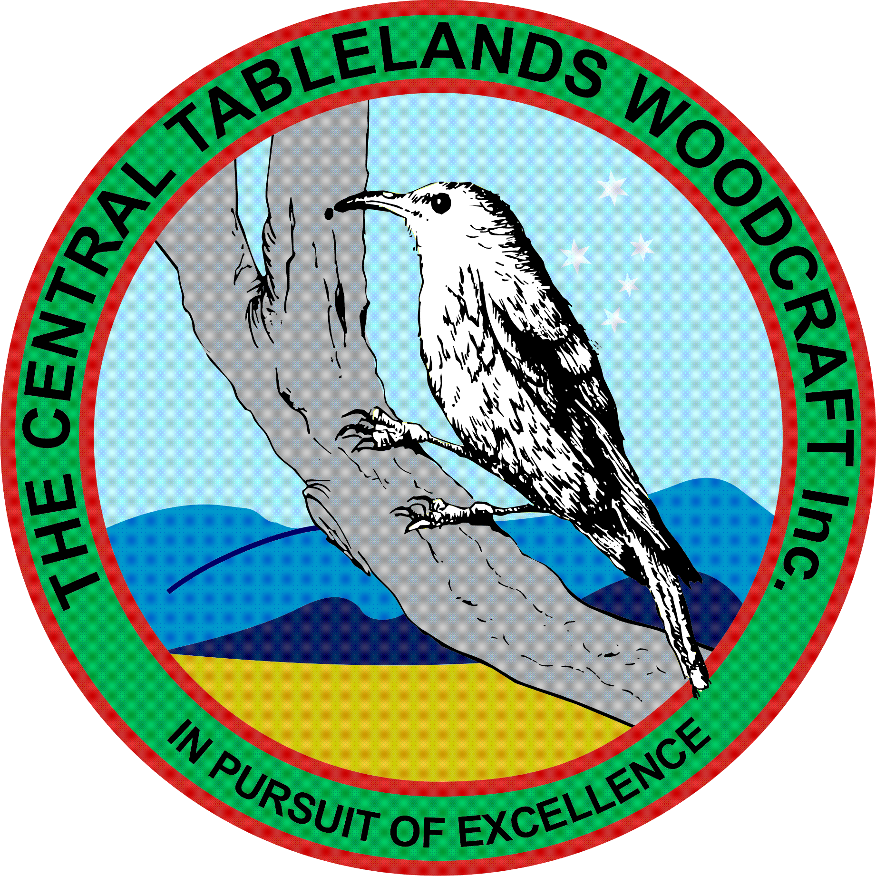
Central Tablelands Woodcraft Newsletter
February 2017
February has seen some of the hottest conditions in recent memory and this has been reflected in the works being done in the Club's workshop in the less than favourable conditions.
The last month has been very busy with many projects being undertaken by the club with the job for Mayfield gardens being the most significant.
Mayfield Gardens requested that the Club make more than a hundred wooden table runners within a very short time span. With this in mind a plan and sample were made, and the materials ordered and a number of working bees planned for Saturdays as well as normally scheduled club days. It was extremely gratifying to see so many members attend these working bees and assist with the making of these table runners. Some members cut the material up, others did the appropriate routing, others cut the scallops from the feet and others assembled the items. There was also a team sanding and another group applying the finish. Everyone got along and all in all everybody worked very well to achieve the goal. This project was worth in excess of $2000.00 to the Club.
Well Done everyone.
Other projects have been completed by the Club namely the honour board for the CWA and weaving loom for a local lady. There are other projects continuing to come in.
A number of new members have joined recently and we have also had a number of members return to the Club. One of the new members is a lady and she has no prior knowledge or skill in woodworking and she is very keen to learn and is currently under the watchful eye of Ian Jackson. Karen has also returned and she is keen to learn some new skills and she too is receiving tuition from Ian Jackson.
Following the Club's decision to discontinue C.A.O.S in its previous form a sub-committee was created, under the chairmanship of John Trollor, to investigate ways the Club can replace the income lost due to C.A.O.S no longer being held. At the meeting a number of recommendations were made to and adopted by the membership. The major recommendation was that the Club participate in Debbie Campbell's Expo held in November. It was also recognised that the Club's members need to enthusiastically participate in these activities so that the load is spread out and not left to a small number of members. (the full list of recommendations will be displayed on the noticeboard).
In order for any marked days or displays to be successful it is necessary for as many members as possible to make items for the Club to sell so please get to it.
In May the Club will be participating in Heritage Week Bathurst Artisan Trades Trail (1 and 14 May at the Tremains Mill). This involves members participating a display of working with hand tools and the like to demonstrate how items were made prior to the current workshop equipment. The Club will be demonstrating wooden toy making, log sawing, hand planing, lathe work. Please advise John if you can assist with this. More information will be posted on the notice board as it comes to hand.
Again I would like to thank all members for their very hard work over the last month or so, you have all done an amazing job

