Central Tablelands Woodcraft Newsletter
June2018
It is necessary to honour and remember the passing Les Bingham Rolls - RIP old friend
Our annual event affectionately known as W.O.S will again take place this year on 17 and 18 November. It is the intention of the Club to again showcase our knowledge and skill to the general public. Whilst our function was very successful the management committee has determined that we will present activities that were successful at Tremains Mill. Ian Jackson will be looking for assistance to present a more varied array of interactive stall. It is also appropriate that ALL members and I mean ALL members (and that does include me) present an item or 2 for the competition - we must view this as a learning tool not a critical tool so that we can improve what we do.
It is intended that the Club holds an "Open Day" on 9 September - this will be advertised on local media.
Members are well underway making items for inclusion in the Operation Christmas Child program this year - please see Brian Clymo or Peter Sparks if you can assist.
The toilet facilities are in dire need of refurbishment and we have applied for a grant to assist in this endeavour. As the cost of the project exceeds the amount available from the grant it will be necessary for members to assist with their labour. There is also an opportunity to engage with business in the area for donations of products for the project. John McMahon is the project lead on this.
It is also necessary to remind members that whilst it is OK to borrow tools from the Club it is appropriate to advise a member of the committee and return it when you have finished. The Japanese pull saws went missing and whilst we have found one the other is still missing.
Another safety familiarisation day has been requested so this will be organised and members advised of the date.
In order for the Club to continue to operate as we historically have ALL members must sign the attendance sheet and pay the daily fee of $3 at the desk located outside the meal room. This money assists with the payment of the electricity and the cups of tea/coffee and biscuits you may consume.
Again it must be pointed out that the office/meeting room is NOT some sort of inner sanctum and must be viewed as an area available to all members to either sit quietly or to warm up on these cold days - so please use it.
Every month following the General Meeting we will be holding our B-B-Q which will be at no cost to members.

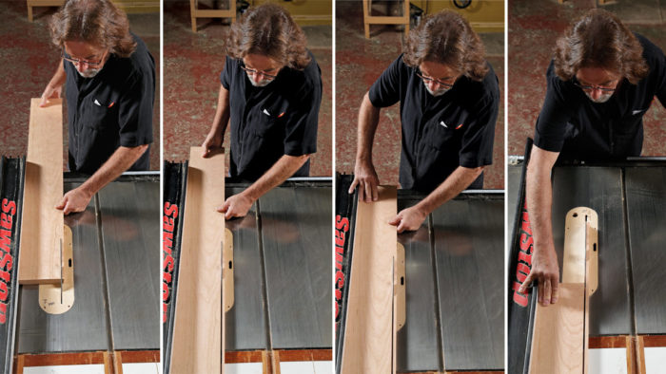

Synopsis: There are a number of things that can go wrong when ripping wood on the tablesaw, chief among them kickback. But ripping is a safe practice if you understand the mechanics of the task. Here, Bob Van Dyke explains a handful of techniques that will keep your rips true and your body safe from kickback. Chief among them are proper milling, understanding blade rotation, where to stand, how to position your hands correctly, when to use push sticks and pads, and how to handle oversize boards.
A tablesaw is the best tool for ripping a board’s edges parallel, but safe and successful ripping on the tablesaw depends on understanding a handful of essential techniques and practices. This article will explore and explain these factors so that you can master the mechanics of ripping.
One important concept to keep in mind is the rotation of the blade. Think of the blade as having a front and a back and remember that as they cut, the teeth in the front push the wood down onto the saw table. At the back, the teeth are rotating up away from the table, and if wood contacts these rising teeth, they’ll exert upward pressure, creating the possibility of kickback. Kickback happens when the back of the blade contacts the edge of the wood with enough force that it grabs the stock and propels it back straight toward you at great speed. I once saw a piece of molding shoot 20 feet across the shop before going completely through two pieces of 3⁄4-in.-thick particleboard. Fortunately, as long as certain practices are followed, kickback is easy to avoid and should never be common.

