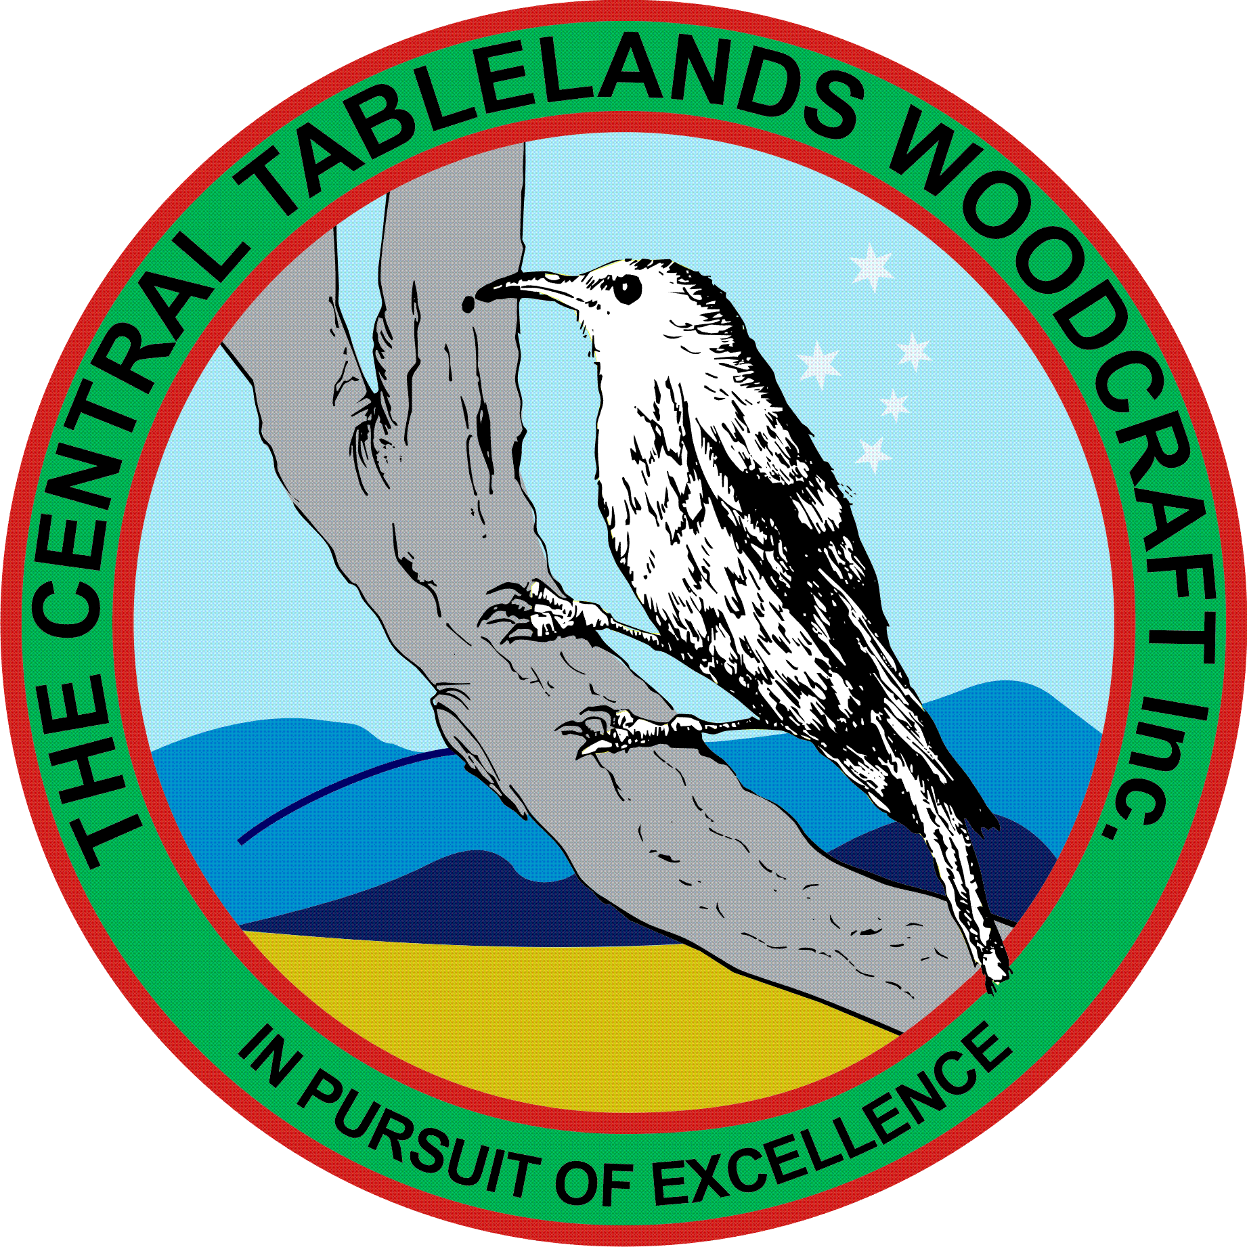
Central Tablelands Woodcraft Newsletter
March 2018

Another year has successfully come to an end with the Annual General Meeting being conducted to elect a new committee for 2018 and the following people were elected"
President: Mike Hardie
Vice President/s: Ian Jackson and John McMahon
Treasurer: Doug Kinlyside
Secretary: Paul Rodenhuis
Committee: Colin Borny, Bob Cassidy, Peter Brennan

All these people were elected unopposed.
At the AGM John McMahon was proposed as a Life Member and all members present agreed that John was worthy of this honour.
A number of items carried over from the previous meeting including the refurbishment of the toilet block to adequately provide for our expanding membership which includes many more woman. Council are being approached to assist with the financing of this project along with seeking a grant through Paul Toole's office.
A number of members attended the Sofala Show which was successful in that many people visited us and discussed woodworking.
Mike Hardie has inspected the first aid kit and determined that it is up to date and all items are current and in date. All members are reminded that if they hold a current First Aid Certificate could they advise the committee so that they can be identified.
Garth and Jacko have organised to participate in Bunnings pre-Easter fair on Thursday 22 March from 1800. They have also recruited a number of other members to assist - and our skills and wares will be showcased. We have also been asked to conduct a guessing competition for Bunnings.
Another visit to the Bathurst City Centre will be held 27-28th April.
The ongoing process of identifying appropriate members to provide suitable instruction and advice on all our equipment Doug has proposed a suitable sign for each machine which will identify who the people are. Whilst this is an ongoing process it is nearing completion.
Planning has commenced for our participation in the Heritage Trades Trail which will be held on 12 and 13 May, - stay tuned.
Jacko is conferring with Debbie Campbell regarding our participation in the markets in November so we will most likely be involved this year - again stay tuned.
We have a lot got a lot of projects on the go - tables for the RFS, dancing dolls, a large toy box and quite a few members are assisting with these projects.
Ron has organised a social outing/lunch 18 April @ 1300 at the Vanilla Bean
It is very satisfying to see the number of members attending the club when we are open and some of the things that are being made are quite intriguing - so keep it up.

