Central Tablelands Woodcraft inc

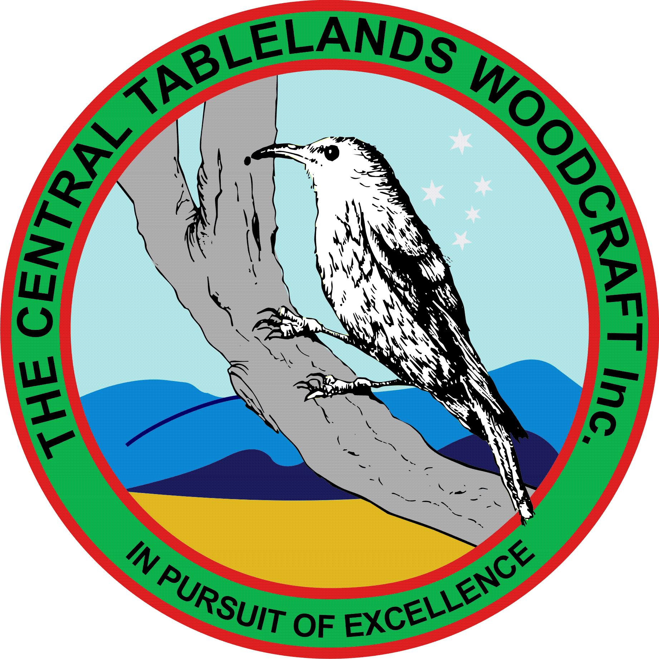

August 2018 Newsletter

With W.O.S fast approaching our focus is now on the planning and preparation for this event. As this is the Club’s major event for the year and that it is the most important way we present ourselves to the general public it is important that ALL members make a huge effort to participate. This means more than ever that it is essential that you make something for the competition – remember we had novices taking out prizes last year – it is also one of the best ways of learning.

This year we will be following on from our successful display and demonstrations from Tremain’s Mill so speak to Jacko to ensure that you can prepare yourselves for this event.

The money that was sought for the making of the street libraries has been made available and plans are being drawn up so that timber can be ordered. Bunnings will be approached for assistance in acquiring the relevant supplies for this job.

With the increased membership of the Club and the subsequent extra demand for the use of certain machinery it has been decided to purchase another planer/thicknesser. This machine would be specifically used for finer more accurate work and older dirty hard wood would be barred.
In order for the workshop space to facilitate such a purchase it was also decided to dispose of the smaller green thicknesser and the lathe located in the corner near the switch board – the disposal of these would be by tender.

Bunnings will again be holding a Father’s Day evening on the 30 August from 1800 to 2030. Last year’s effort was successful so Jacko and Garth will again be attending so if you wish to participate please advise one of them.

The Visitor’s Centre management have approached the Club to sell items made from local timber at their premises. Whilst there are still some details to be confirmed it was decided to accept their offer.

The “hat” that was available for donations for the farmers appeal rendered $600 which was duely passed to the collection point. ALL this money (no admin fees) was put to the purchase of shopping vouchers for inclusion in “hampers” for the benefit of the struggling farmers.

Currently the Club subscribes to the Australian Woodworker and it was decided that we subscribe to the Australian Woodsmith as well.

The metal detector currently located in the meeting room will be relocated into the workshop.

The spatula making workshop conducted recently by Allan Rintoul was very successful and another such workshop may be run in the future.

