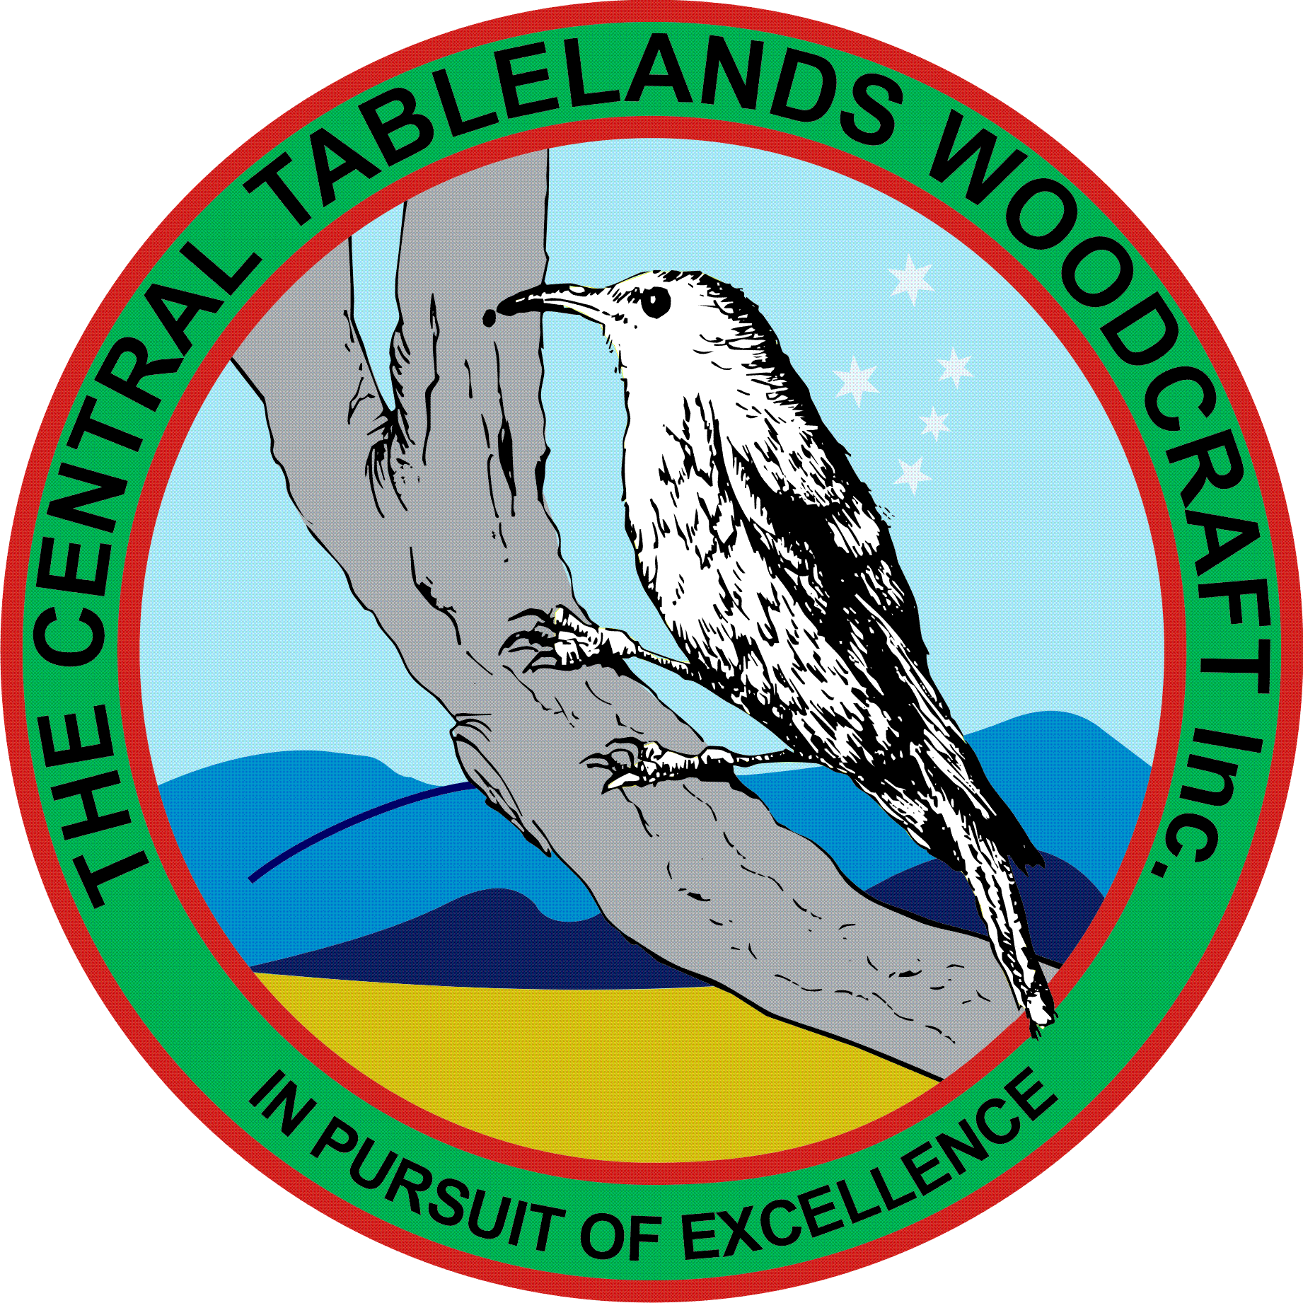
Central Tablelands Woodcraft Newsletter
November 2018
Well let me firstly congratulate ALL those members who attended the Woodcraft on Show and assisted by manning tables and stalls – your efforts went a long way to making the show a great success.
The grant that was applied for to refurbish the toilet block has been approved and the next step will be taken to start the ball rolling – John McMahon and Mike Hardy.
There were a number of things that came out of WOS namely the removal of the art that was placed on show – also the competition judges provided a great deal of feedback regarding entries and Jacko will discuss this with members if they wish.
The items that were requested to be provided for the Visitor Information Centre have been tagged and sent – ALL members are reminded that ANY item provided for sale through the Club must be appropriately tagged or it won’t be accepted.
Our members who have put in a great this month are Phil Hill for the refurbishment of the treadle table saw and Graham Moon for his work on the tables and chairs – well done guys.
THE CLUB WILL BE CLOSED BOXING DAY.
The Club Christmas Party will again be held at the Club facility on Friday 14 December starting at 1800hrs - $15 a head for ALL attendees
Unfortunately Colin Borny has withdrawn from the management committee due to ill health – he will still attend the workshop however and will ALWAYS be welcome.
There are a number of projects that have been accepted by the Club – more shelving for the Historical Society – Eglinton School have requested a “Buddy Chair”
The winners of the raffle are - Ian Brewer #0065, Martin #0999, Greg Pitt #513
Congratulations to those winners.

